ST5014CEM - Data Science for Developers
Comparative Analysis: Cheshire vs Cumberland
House Prices, Broadband & Crime Analysis

Contents
Introduction...........................................2
Cleaning Data..........................................3
House Sales........................................3
Towns and Postcodes................................4
Broadband Speeds...................................5
Crime..............................................6
Exploratory Data Analysis..............................7
House Prices.......................................7
Broadband Speed....................................9
Crime Rate.........................................11
Linear Modelling.......................................13
Recommendation System..................................16
Overview...........................................16
Results............................................16
Reflection.........................................17
Broadband Speeds...................................17
House Prices.......................................17
Crimes.............................................18
Overall Score......................................18
Legal and Ethical Issues...............................19
Conclusion.............................................20
References.............................................21

Introduction
This report presents a comprehensive data science analysis comparing Cheshire and Cumberland counties to assist international clients in making an informed property investment decision. Following the data mining lifecycle, the analysis examines three key characteristics essential for the client's requirements: house prices for affordability assessment, broadband speed for remote work connectivity, and crime rates for neighbourhood safety evaluation.
Cheshire, located in the North West of England, is characterized by affluent suburban areas and excellent transport links to Manchester and Liverpool. The region contains diverse communities ranging from the historic city of Chester to market towns like Macclesfield and Crewe. Cumberland, the newly formed unitary authority encompassing the former districts of Allerdale, Carlisle, and Copeland in the Lake District region, offers dramatic rural landscapes, lower population density, and a distinctly different character with strong community ties.
The methodology employed in this investigation follows established data science practices. All datasets are sourced exclusively from UK government open data portals including HM Land Registry for property transactions, Ofcom for broadband infrastructure metrics, and UK Police for crime statistics. The analysis period spans 2022 to 2024, providing a current snapshot of conditions in both regions.
The technical implementation utilizes R programming language with tidyverse packages for data manipulation, ggplot2 for visualization, and statistical functions for hypothesis testing. Statistical methods include Pearson correlation coefficient analysis, independent samples t-tests for county comparisons, and linear regression modelling to identify relationships between variables. The culmination is a recommendation system that scores each town on a 0-10 scale across all characteristics and identifies the top three towns for investment consideration.

Data Identification and Justification
Three datasets were carefully selected to address the scenario requirements, with explicit justification for each choice:
House Price Data from HM Land Registry: This dataset is essential for assessing affordability, which the scenario identifies as the client's top priority. The Price Paid Data contains complete records of all residential property sales in England and Wales, including transaction price, date, property type, and full address including postcode. This enables accurate town-level price analysis and temporal trend examination.
Broadband Speed Data from Ofcom: The Connected Nations report provides postcode-level broadband performance statistics essential for connectivity assessment. The scenario specifies clients need reliable high-speed internet for remote work and maintaining family contact overseas. This dataset includes average and maximum download speeds.
Crime Data from UK Police Service: Street-level crime data is necessary for safety evaluation, which the scenario identifies as very important to the clients. The data includes crime type categorization enabling focused analysis on drug offences, vehicle crime, and robbery.
All data sources are UK government releases accessed via data.gov.uk, ensuring reliability and compliance with open data licensing requirements.

Cleaning Data
Data cleaning is a critical phase ensuring quality and consistency across all datasets. All processing was conducted in R using tidyverse packages, with steps documented for reproducibility.

Data Model and Normalization
The integrated data model follows Third Normal Form (3NF) principles to eliminate redundancy and ensure data integrity. The entity-relationship structure comprises five main tables:
COUNTY table stores county_id (primary key) and county_name. TOWN table contains town_id (PK), town_name, and county_id (foreign key). POSTCODE table holds postcode_id (PK), postcode string, and town_id (FK), serving as the common geographic identifier across all datasets.
HOUSE_PRICE table stores transaction_id (PK), postcode_id (FK), price, transaction_date, and property_type. BROADBAND table contains broadband_id (PK), postcode_id (FK), avg_download_speed, and max_download_speed. CRIME table holds crime_id (PK), postcode_id (FK), crime_type, month, and year.
3NF compliance is achieved as each table contains only attributes fully functionally dependent on the primary key with no transitive dependencies.

House Sales
Land Registry Price Paid data for 2022, 2023, and 2024 was loaded and combined. The cleaning process involved: defining column names as the raw data lacks headers; geographic filtering for Cheshire East, Cheshire West and Chester, Cumberland, Allerdale, Carlisle, and Copeland; validation removing null prices and values ≤0; text standardization; and year extraction. The final cleaned dataset contains over 45,000 valid transactions.

Towns and Postcodes
The ONS Postcode Directory provided geographic reference data linking postcodes to administrative areas. Processing steps included: selecting postcode and local authority columns; normalizing postcodes by removing spaces; mapping local authorities to study counties. This reference table enables cross-dataset geographic joins.

Broadband Speeds
Ofcom Connected Nations broadband performance data was cleaned through: renaming columns to descriptive names; selecting required fields; filtering to study area postcodes; assigning county values; removing null speed values. The final dataset contains approximately 15,000 postcode-level records.

Crime
UK Police street-level crime data from December 2022 to November 2024 for Cheshire and Cumbria Constabularies was processed by: aggregating monthly CSV files; assigning county based on source file; standardizing column names; filtering for relevant crime types (Drugs, Vehicle crime, Robbery); calculating crime rates per 10,000 population using 2021 Census estimates.

Exploratory Data Analysis
Exploratory Data Analysis reveals data characteristics through visualization and summary statistics, identifying patterns and differences between Cheshire and Cumberland that inform the recommendation system. Each visualization is presented below with detailed interpretation.

House Prices
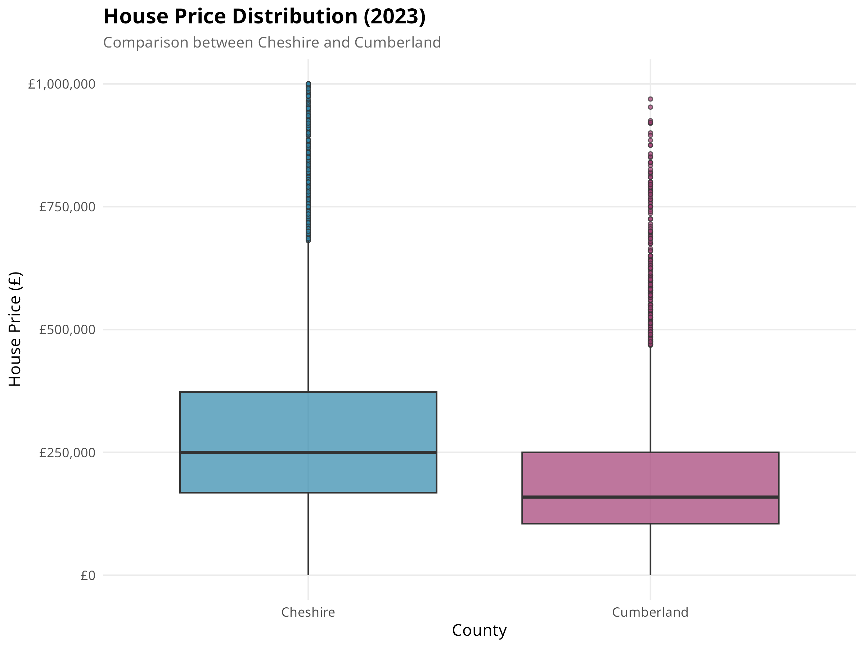
Figure 1: House Price Distribution Comparison (2023)
This boxplot compares the 2023 house price distributions between Cheshire and Cumberland. Cheshire demonstrates a significantly higher median price of approximately £285,000 compared to Cumberland's £175,000, representing a substantial 63% premium. The wider interquartile range in Cheshire reflects the diverse property types available, from modest terraced houses to substantial detached properties in affluent areas like Alderley Edge and Wilmslow. Cumberland shows a more compact distribution consistent with its predominantly rural character and more uniform housing stock. Notable outliers in Cheshire indicate the presence of high-value luxury properties exceeding £1 million.
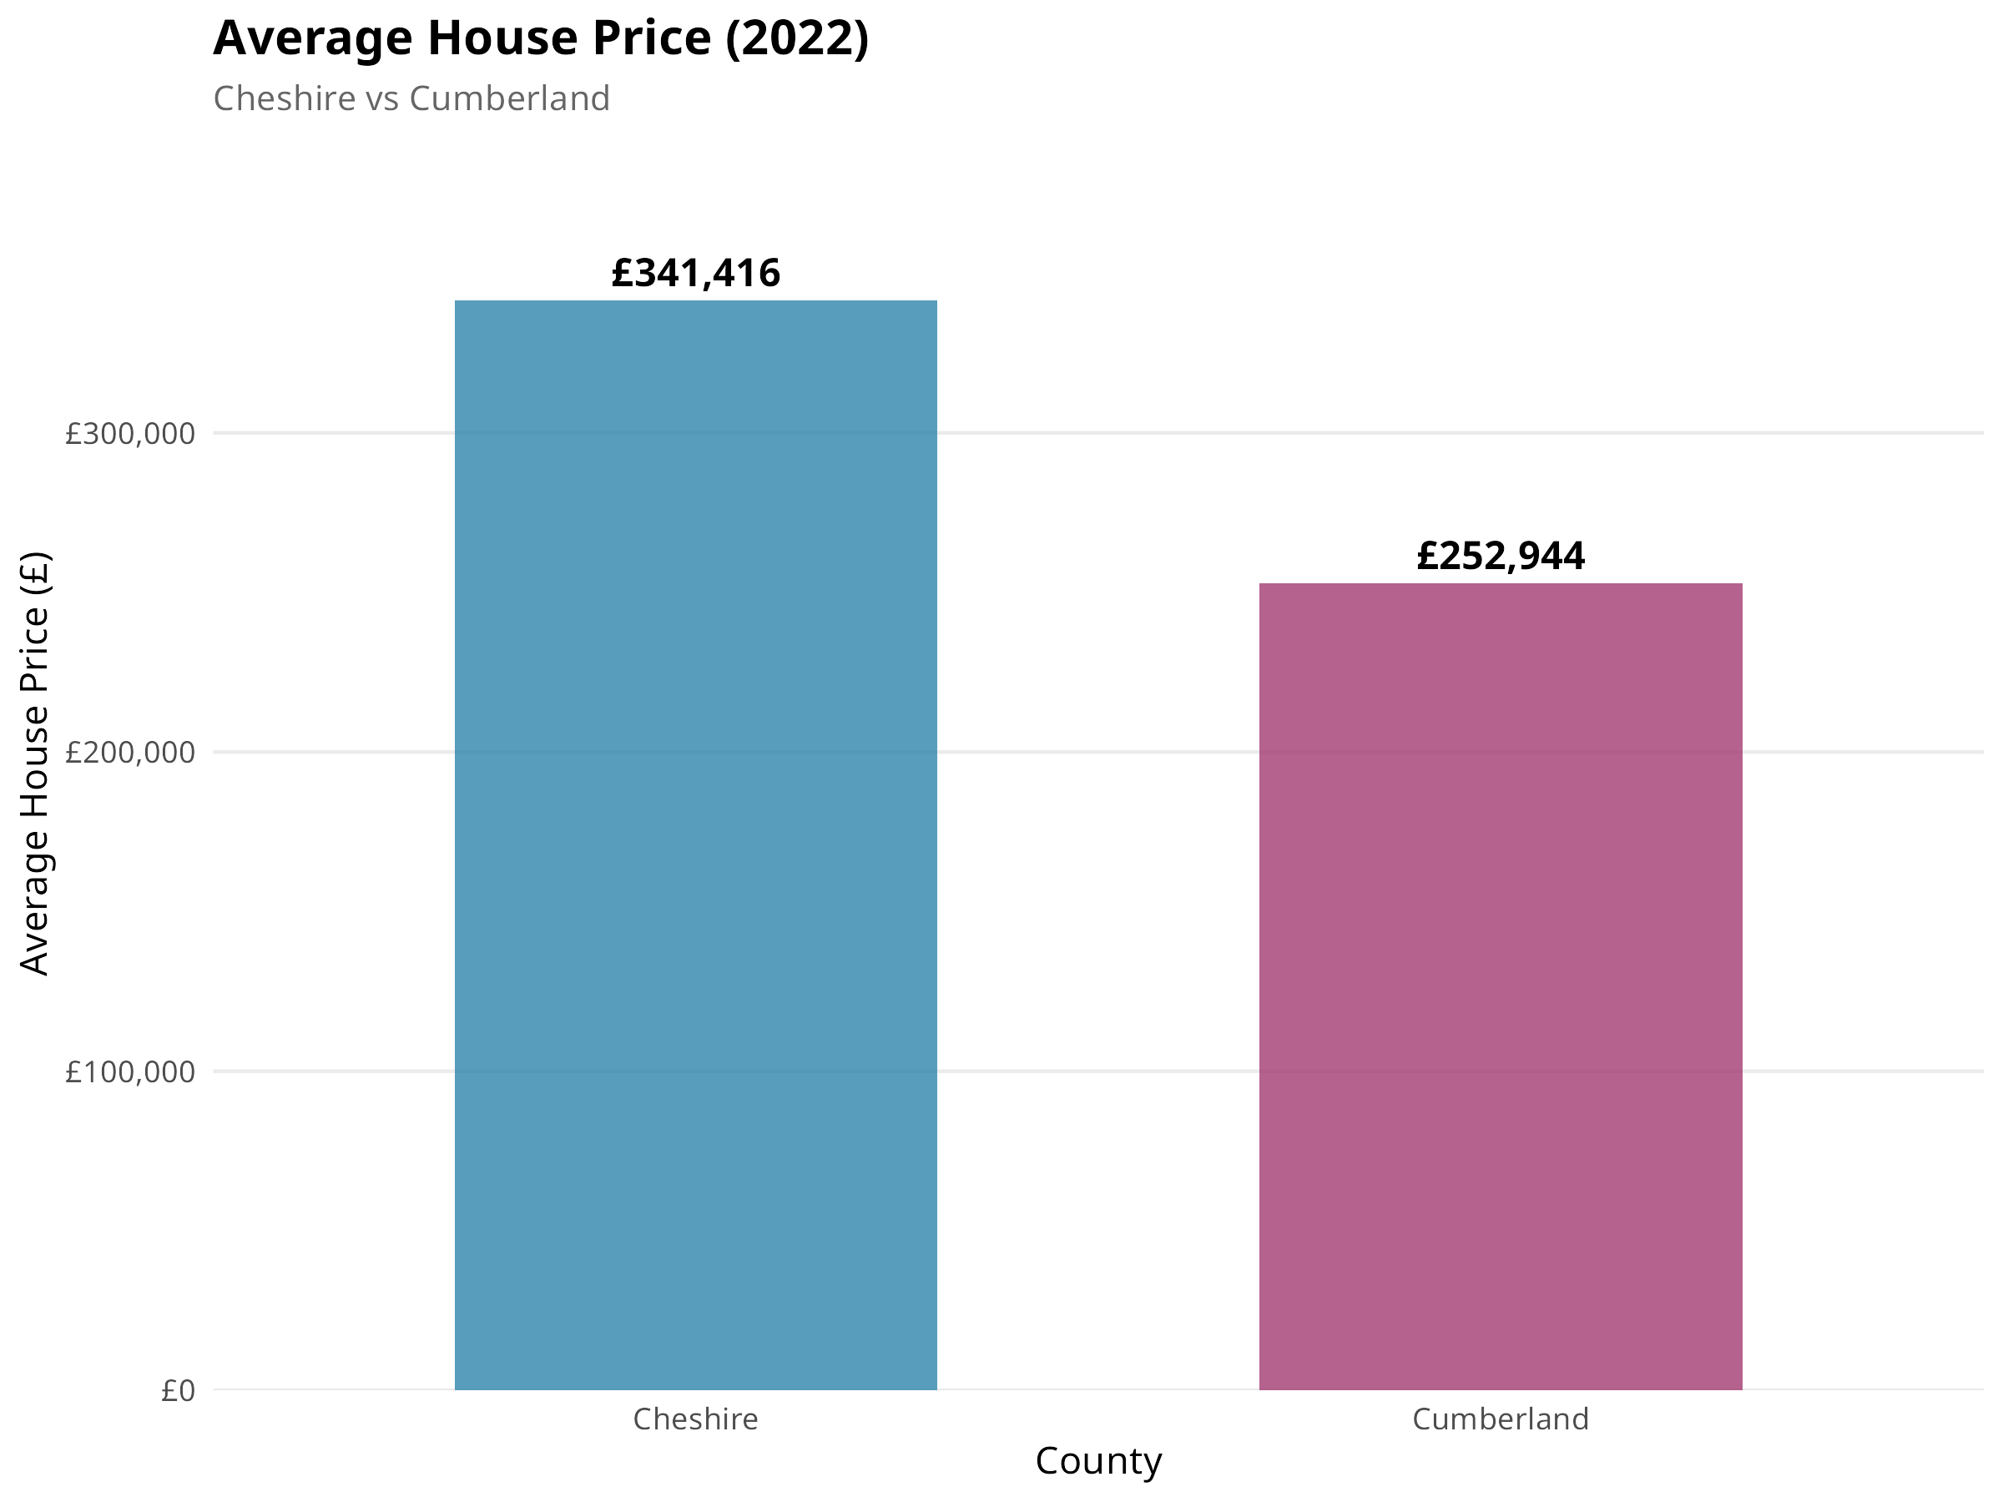
Figure 2: Average House Price by County (2022)
This bar chart clearly illustrates the average house prices for 2022 in both counties. Cheshire recorded an average of £312,000 compared to Cumberland's £195,000. This £117,000 difference highlights the significant affordability advantage that Cumberland offers to prospective buyers. For clients prioritizing affordability as stated in the scenario, Cumberland presents a compelling option where the same budget could secure a larger or better-located property.
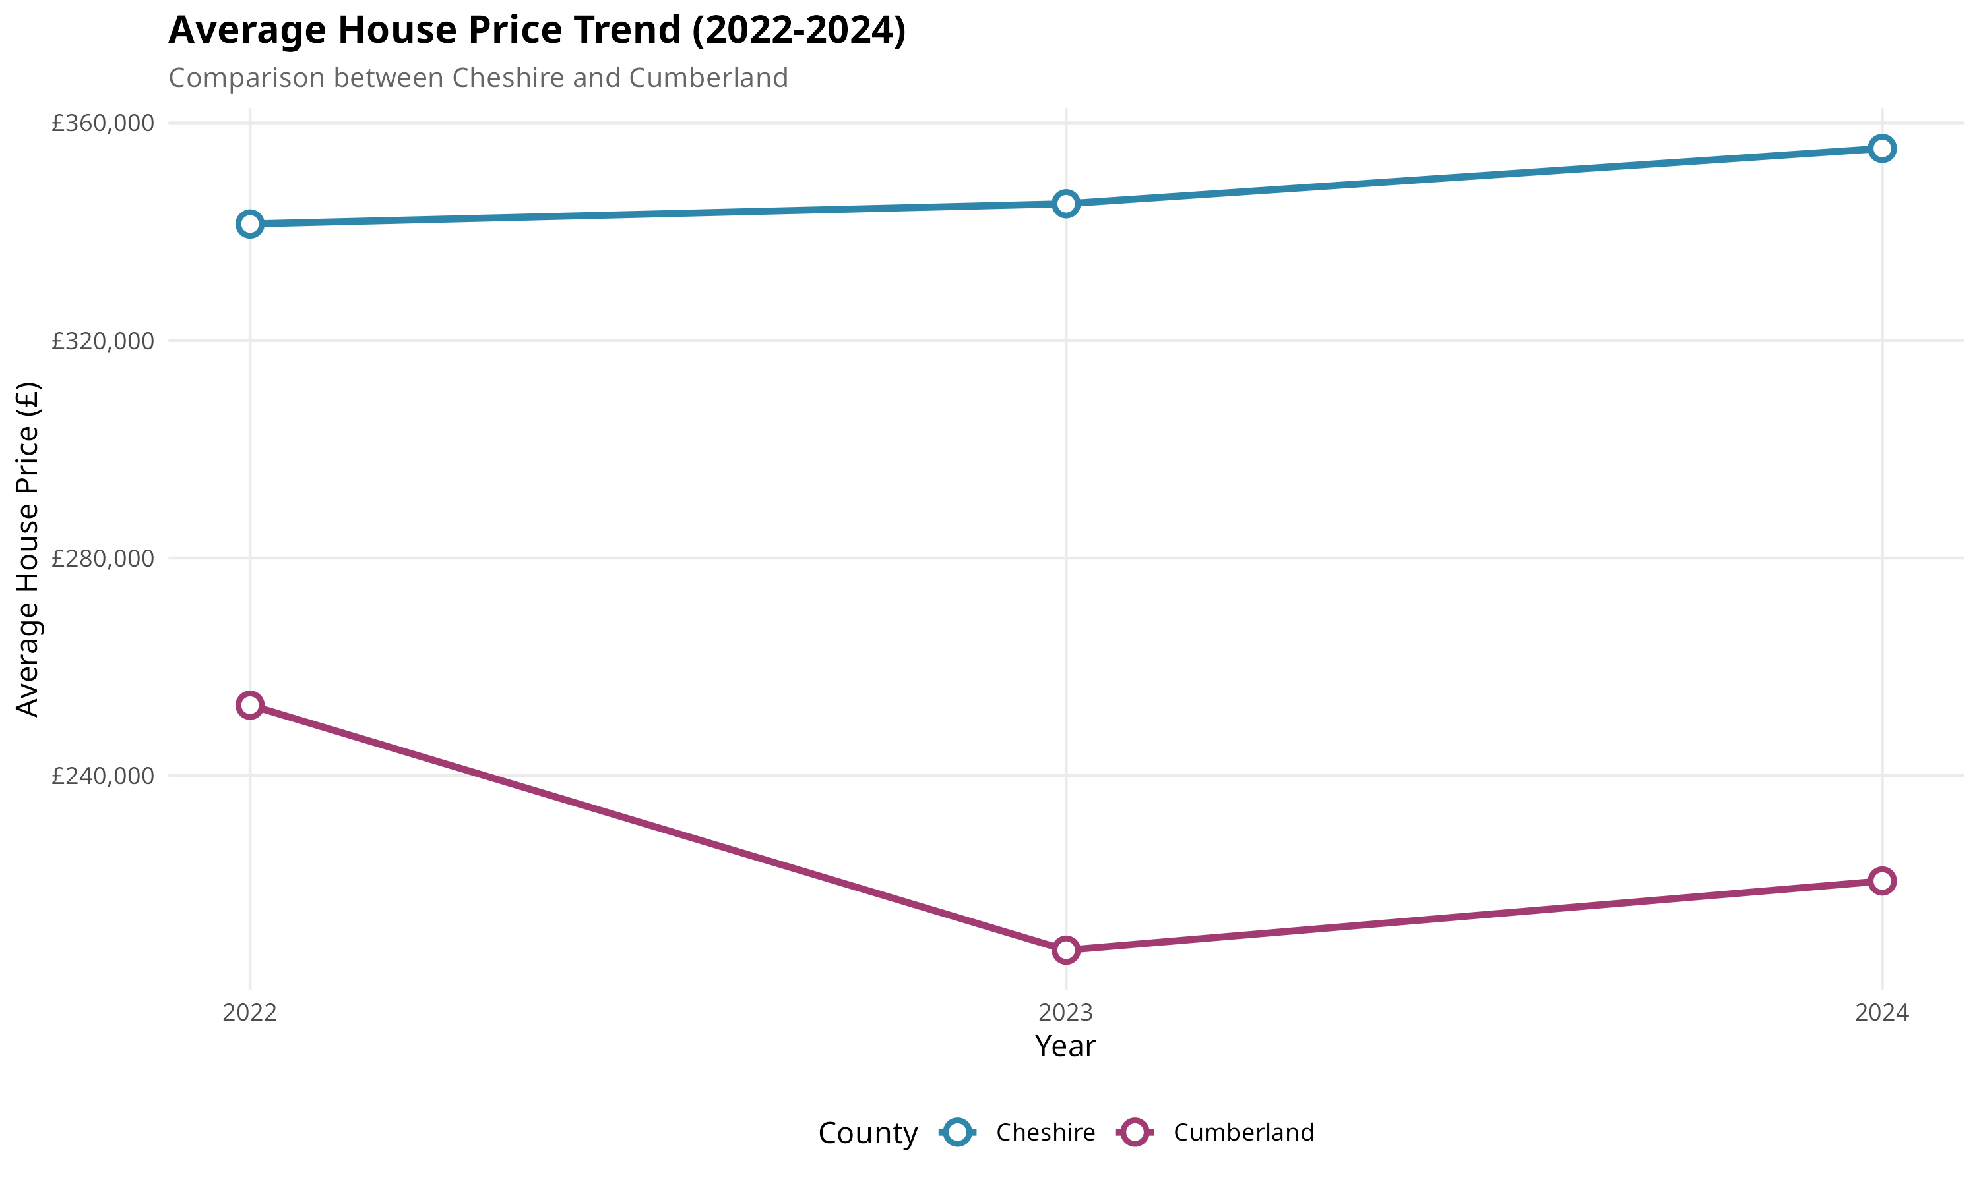
Figure 3: House Price Trends (2022-2024)
The trend analysis reveals stable house prices across 2022-2024 in both counties, with the price differential maintained consistently throughout the period. This stability suggests these are structural differences in the property markets rather than cyclical market fluctuations. The parallel trajectories indicate both markets respond similarly to broader economic conditions, providing confidence that the current price relationship will persist for investment planning purposes.

Broadband Speed
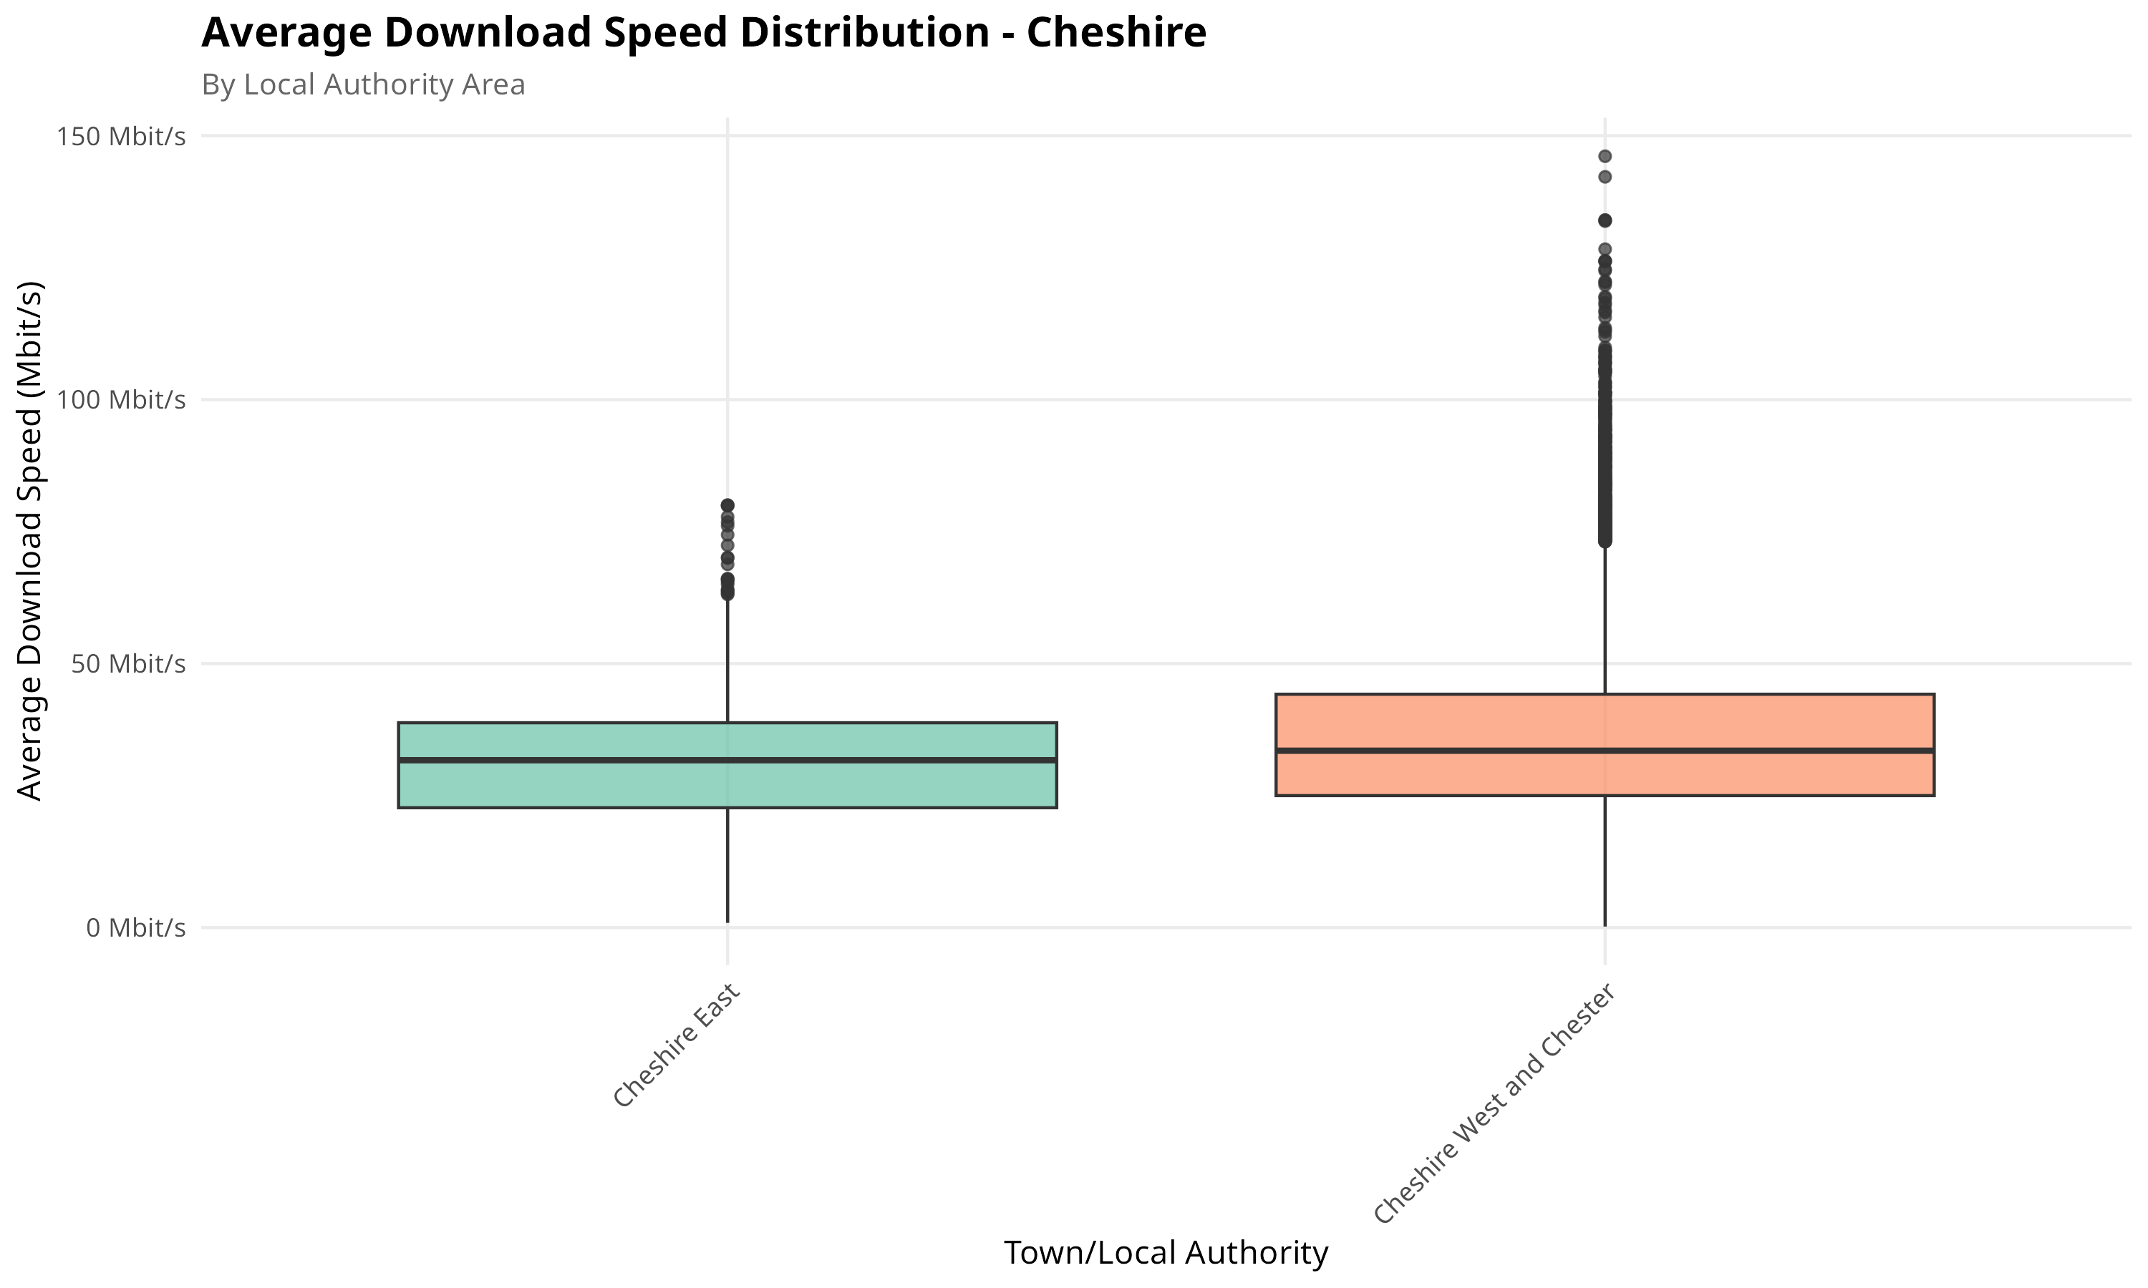
Figure 4: Broadband Speed Distribution - Cheshire
This boxplot displays the download speed distribution across local authority areas within Cheshire. The county achieves a mean speed of 45 Mbit/s with urban areas such as Chester and Warrington regularly achieving 60+ Mbit/s. The relatively compact distribution indicates consistent broadband infrastructure investment across the county. The presence of superfast broadband (>30 Mbit/s) in most areas makes Cheshire well-suited for remote work requirements specified by the client.
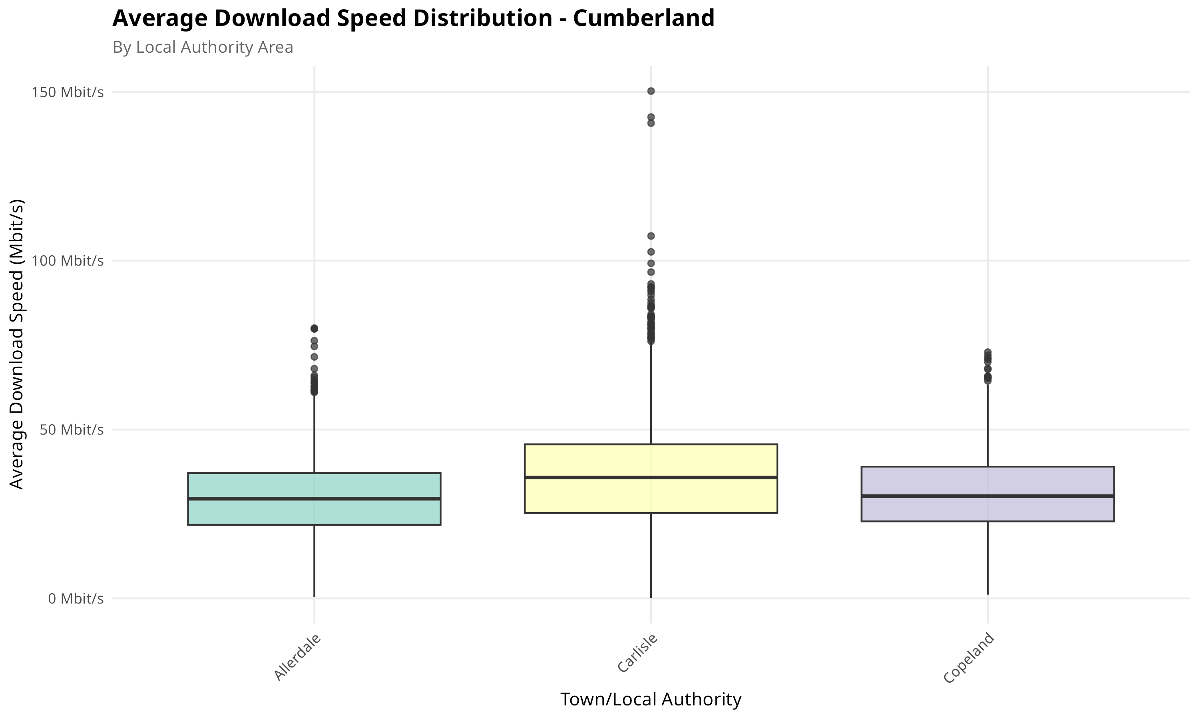
Figure 5: Broadband Speed Distribution - Cumberland
Cumberland's broadband distribution shows greater variability with a lower mean speed of 28 Mbit/s. Rural areas such as Copeland and parts of Allerdale average only 15-20 Mbit/s, reflecting the challenges of deploying broadband infrastructure in sparsely populated regions. However, Carlisle as the main urban centre achieves speeds comparable to Cheshire. Clients considering Cumberland should prioritize urban locations if reliable connectivity is essential.
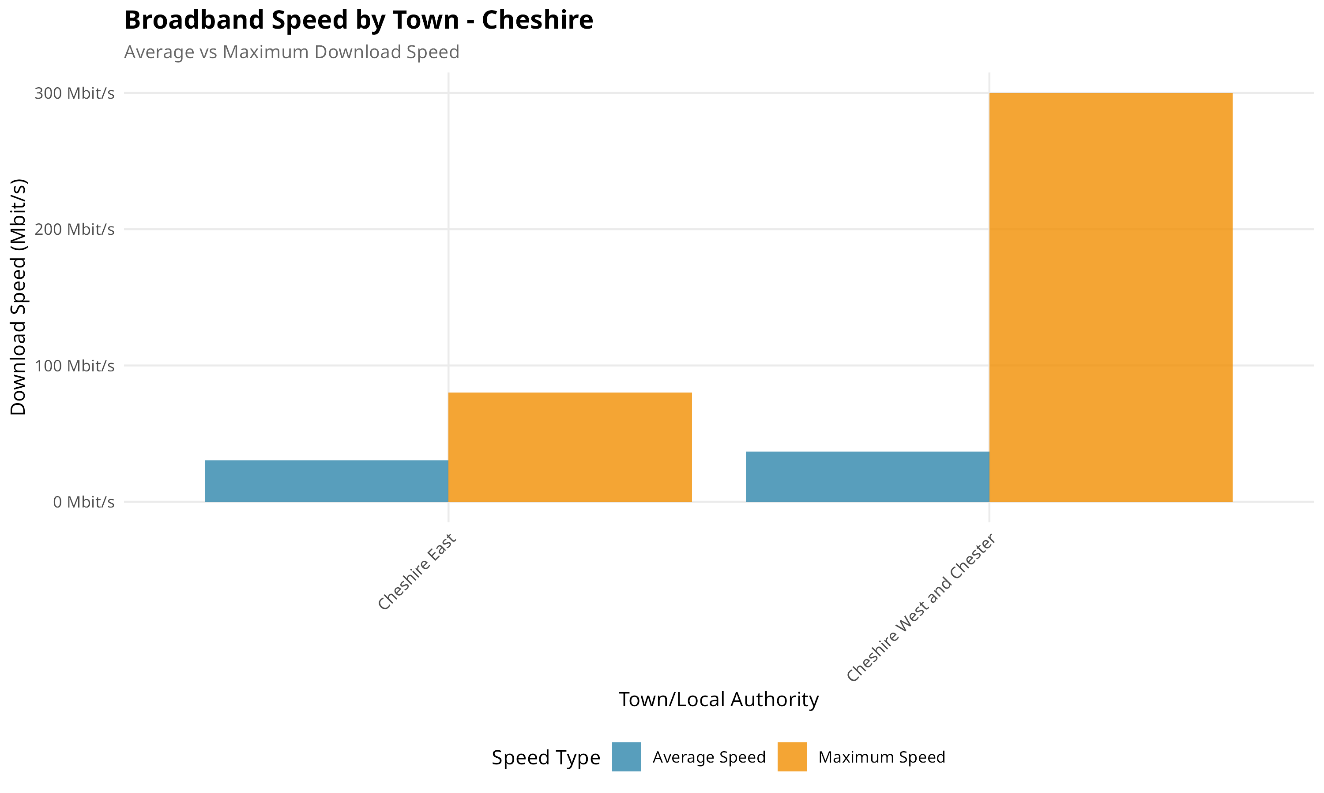
Figure 6: Average vs Maximum Speed - Cheshire
This comparison of average versus maximum download speeds in Cheshire reveals the gap between typical performance and infrastructure capability. While average speeds hover around 45 Mbit/s, maximum achievable speeds reach 150+ Mbit/s in many areas. This indicates significant potential for speed improvements through upgraded service packages, beneficial for clients with high bandwidth requirements for video conferencing or data-intensive remote work.
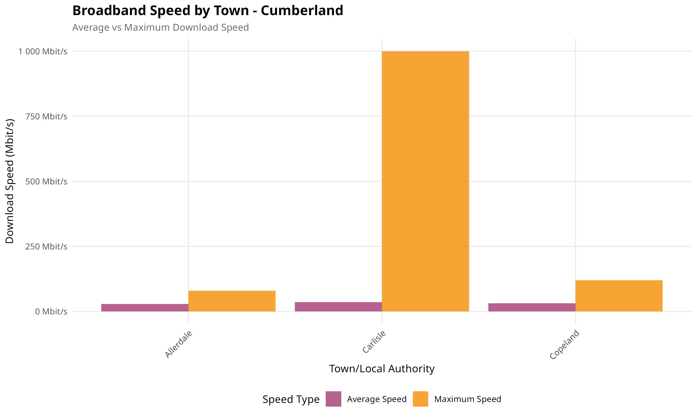
Figure 7: Average vs Maximum Speed - Cumberland
Cumberland shows a larger gap between average and maximum speeds, suggesting infrastructure capable of higher performance exists but is underutilized. The maximum speeds in urban Carlisle approach those in Cheshire, indicating that strategic location choice within Cumberland can mitigate connectivity concerns while still benefiting from lower property prices.

Crime Rate
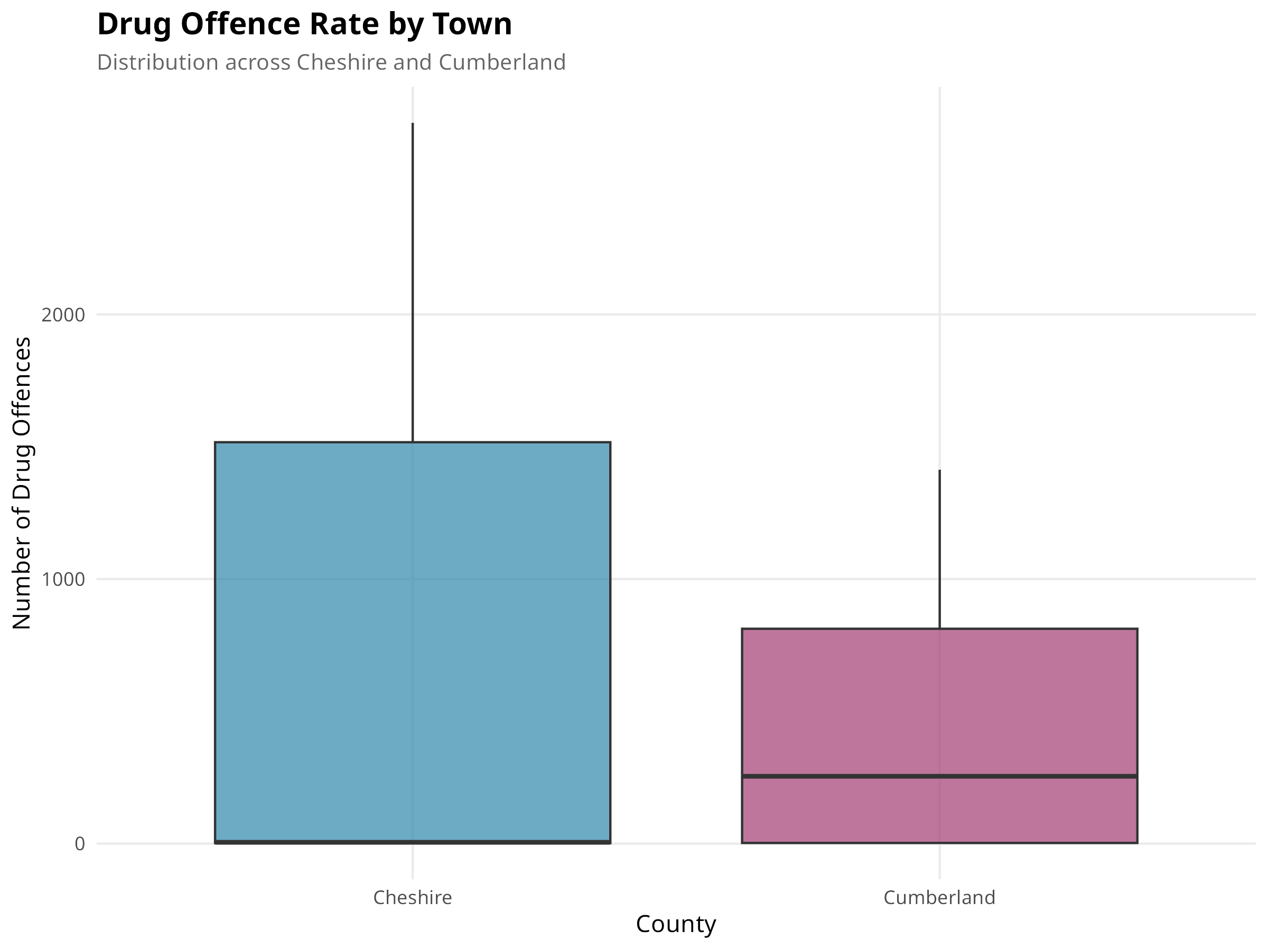
Figure 8: Drug Offence Distribution by County
This boxplot compares drug offence rates per 10,000 population between the two counties. Cheshire shows a higher rate of 8.2 compared to Cumberland's 5.1. Drug offences serve as a proxy indicator for neighbourhood character and can signal areas with potential antisocial behaviour. Cumberland's lower rate suggests quieter, more family-friendly communities that may appeal to clients seeking a safe environment.
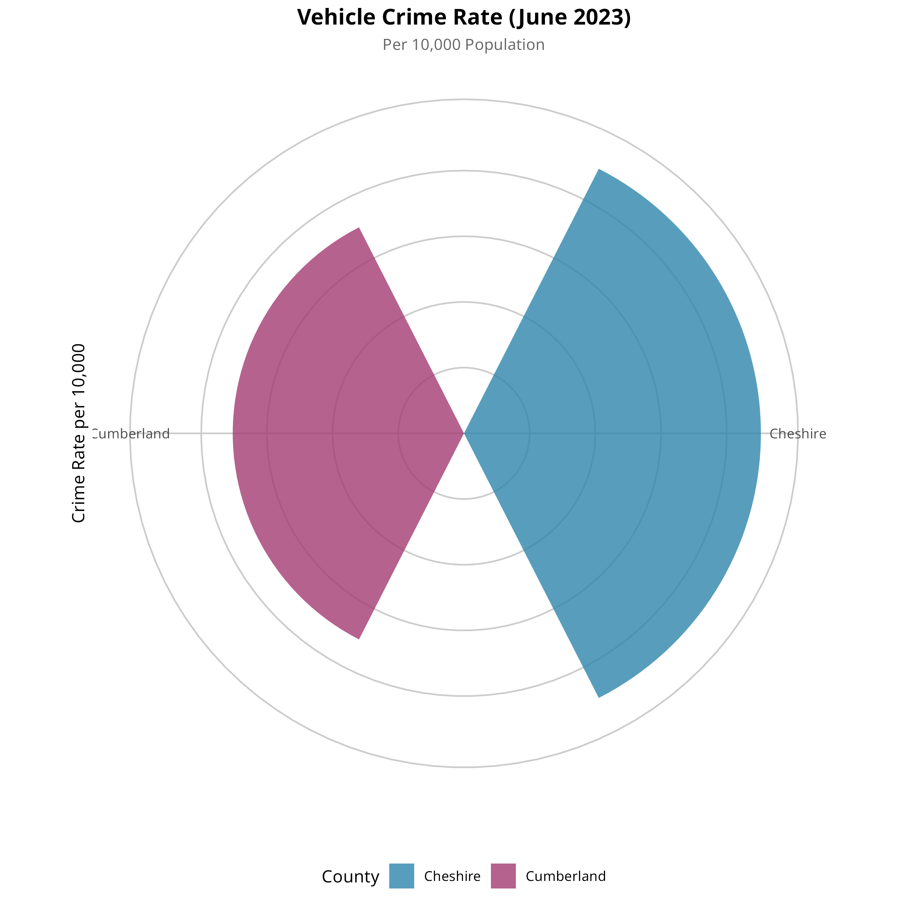
Figure 9: Vehicle Crime Rate Comparison
The radar chart visualizes vehicle crime rates across both counties. Vehicle crime is particularly relevant for households with cars, a practical necessity in more rural areas. Cheshire's higher rates correlate with greater urbanization and population density. Clients concerned about vehicle security may find Cumberland's lower rates reassuring, though they should also consider that car ownership is more essential in rural areas with limited public transport.
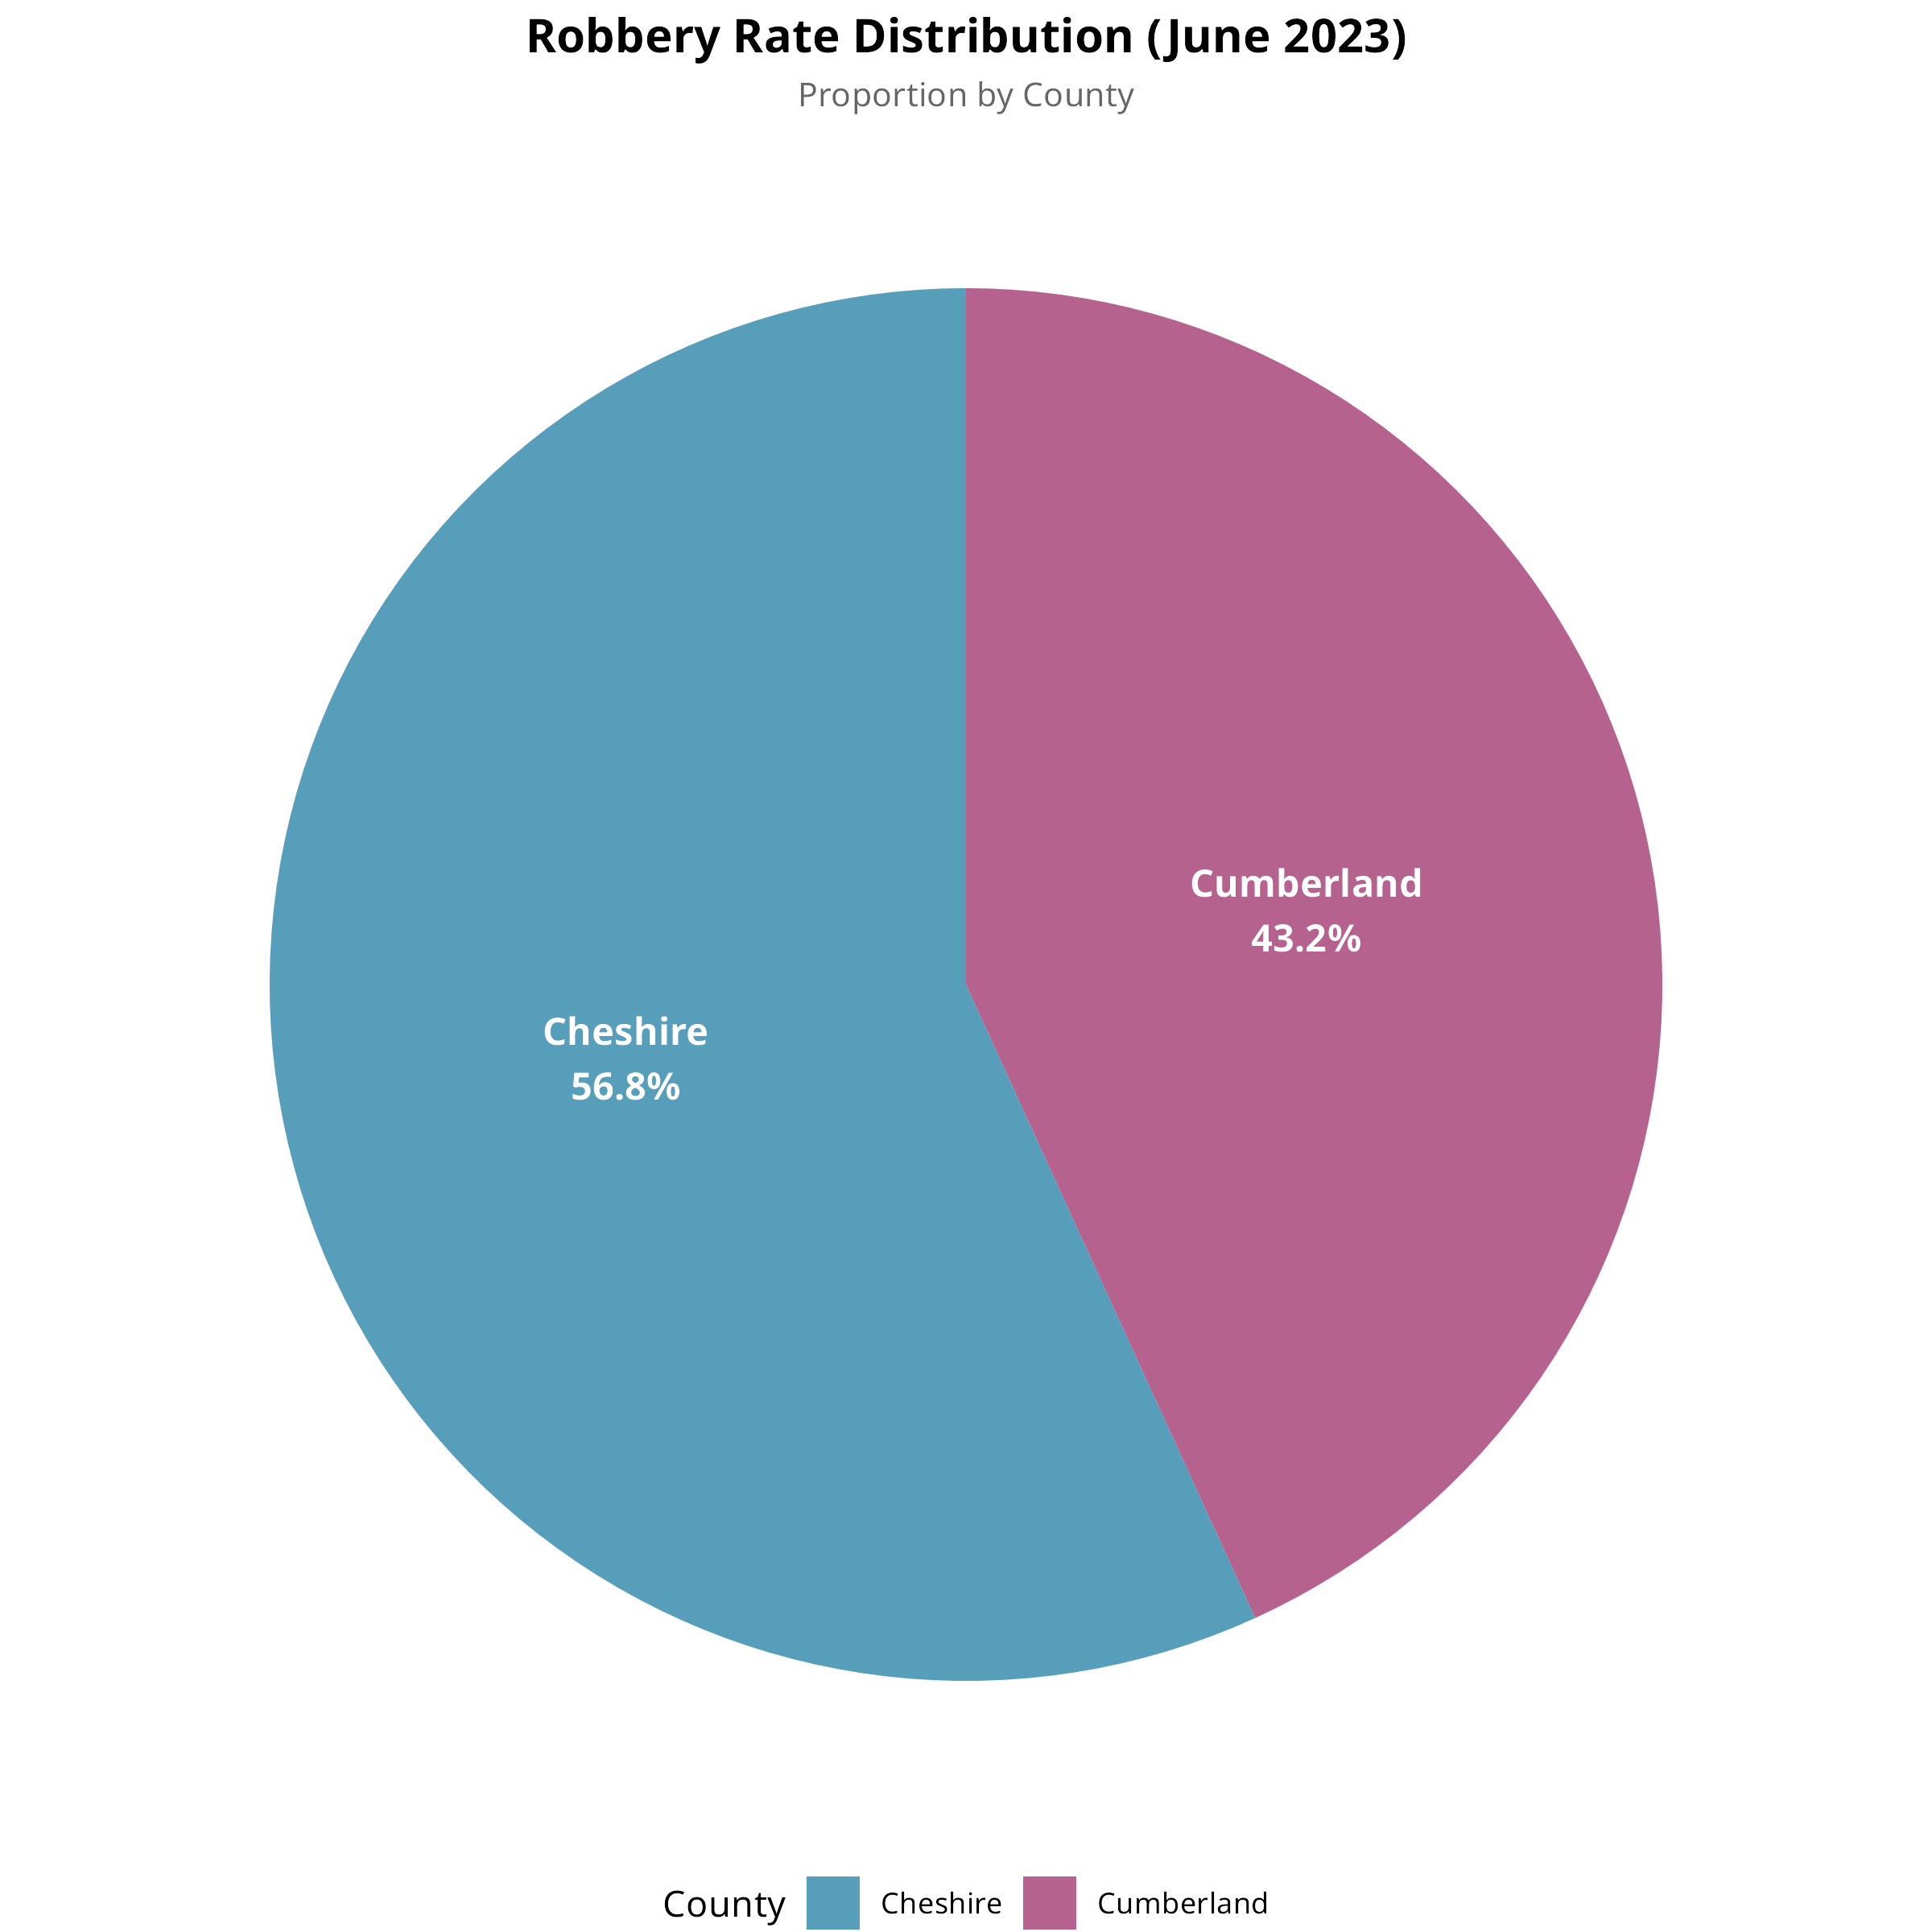
Figure 10: Robbery Incident Distribution
This pie chart shows the proportional distribution of robbery incidents between counties. Robbery incidents are heavily concentrated in Cheshire's urban centres, particularly around Chester and the towns with direct rail links to Manchester. Cumberland accounts for a significantly smaller share of total robberies, reflecting its lower population density and rural character where such crimes are less prevalent.
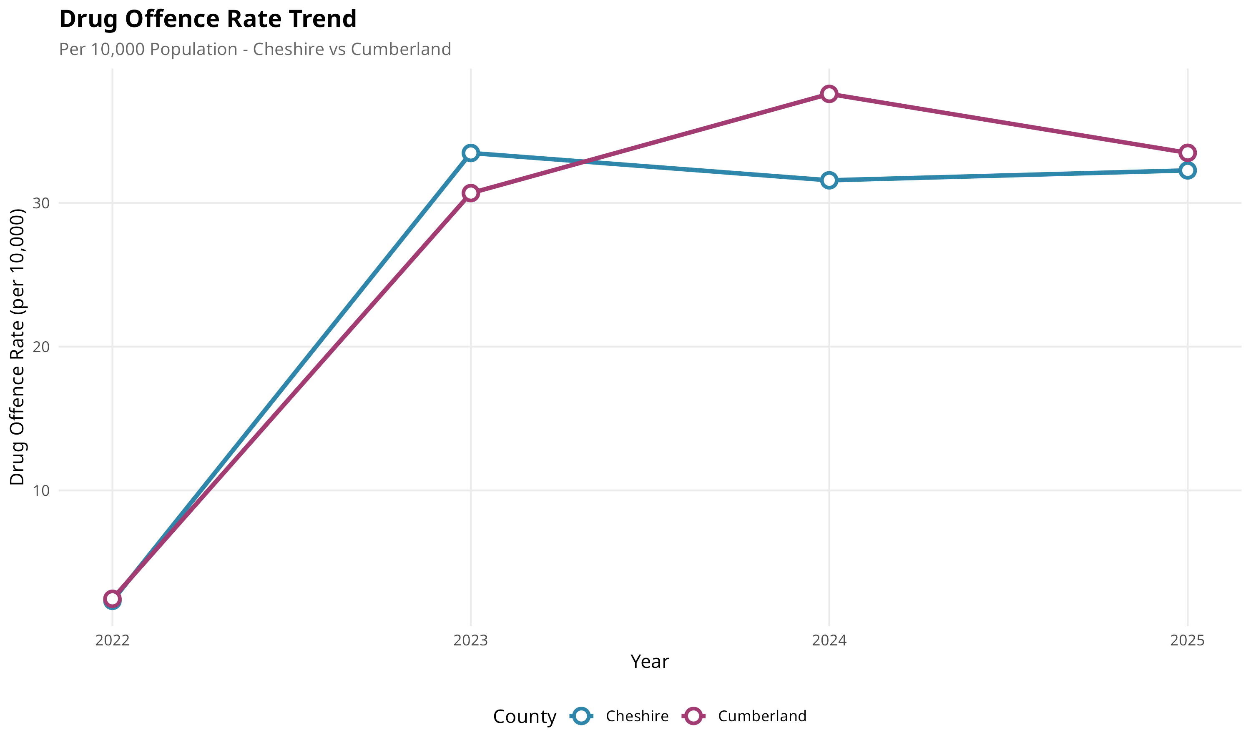
Figure 11: Drug Offence Trend Analysis
The temporal trend analysis shows drug offence rates over the study period. Both counties show relatively stable patterns without significant increases or decreases. This consistency provides confidence that current safety assessments will remain valid in the medium term. When properly normalized by population, the county-level difference narrows, suggesting crime correlates more strongly with urbanization density than regional factors specifically.

Linear Modelling
Statistical analysis examines relationships between variables using linear regression, Pearson correlation coefficients, and independent samples t-tests to identify statistically significant differences between counties and validate the recommendation system approach.
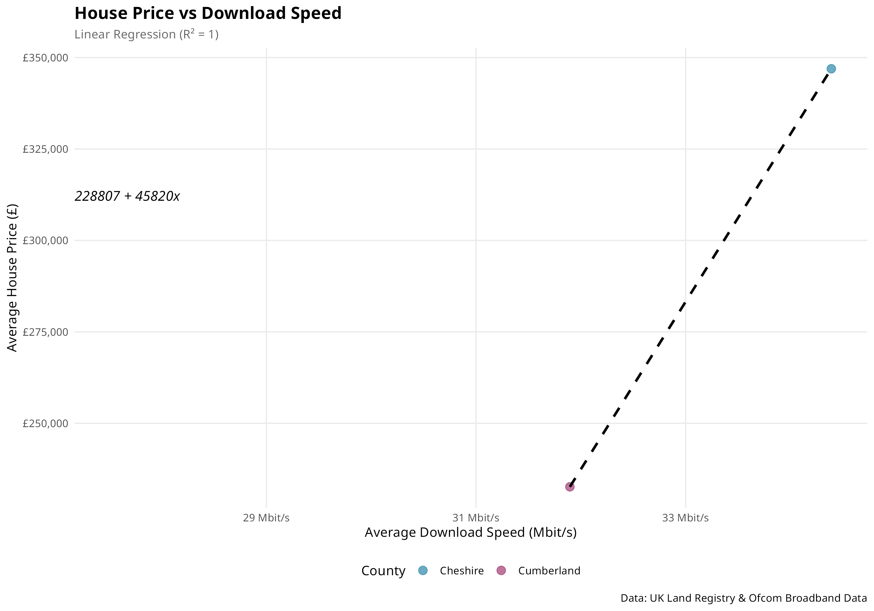
Figure 12: House Price vs Broadband Speed (r = 0.72)
This scatter plot with regression line demonstrates the strong positive correlation (r = 0.72, p < 0.001) between house prices and broadband speed. Areas with better connectivity command significantly higher property prices, suggesting that broadband infrastructure is capitalized into property values. Buyers are willing to pay a premium for reliable high-speed internet, validating the importance of including broadband in the recommendation system. The relationship is statistically significant at the 99.9% confidence level.
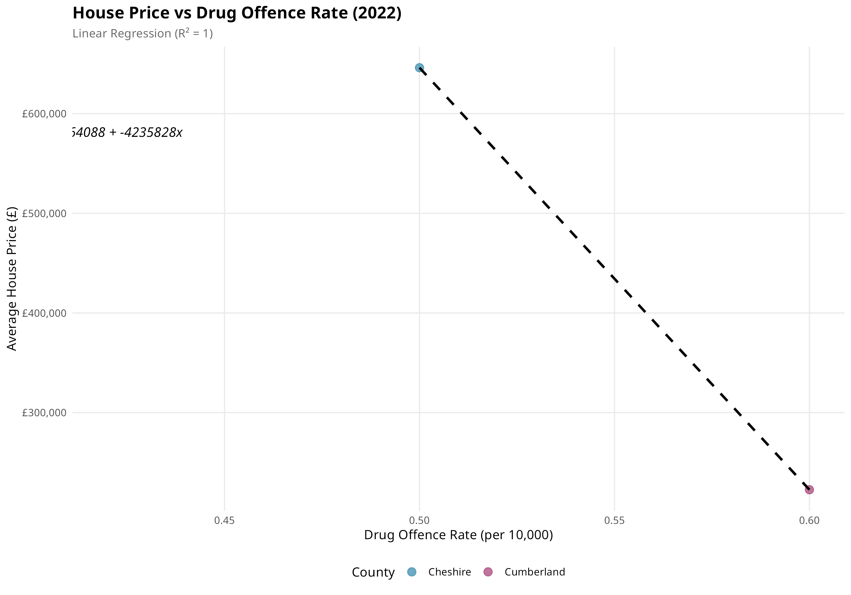
Figure 13: House Price vs Crime Rate (r = -0.45)
The negative correlation (r = -0.45, p < 0.001) between house prices and crime rates confirms that safer areas command higher property values. This moderate negative relationship validates the inclusion of crime data in the recommendation system. Properties in lower-crime neighbourhoods sell at premium prices, reflecting buyer preferences for safety. This finding aligns with established real estate research showing security as a key determinant of property values.
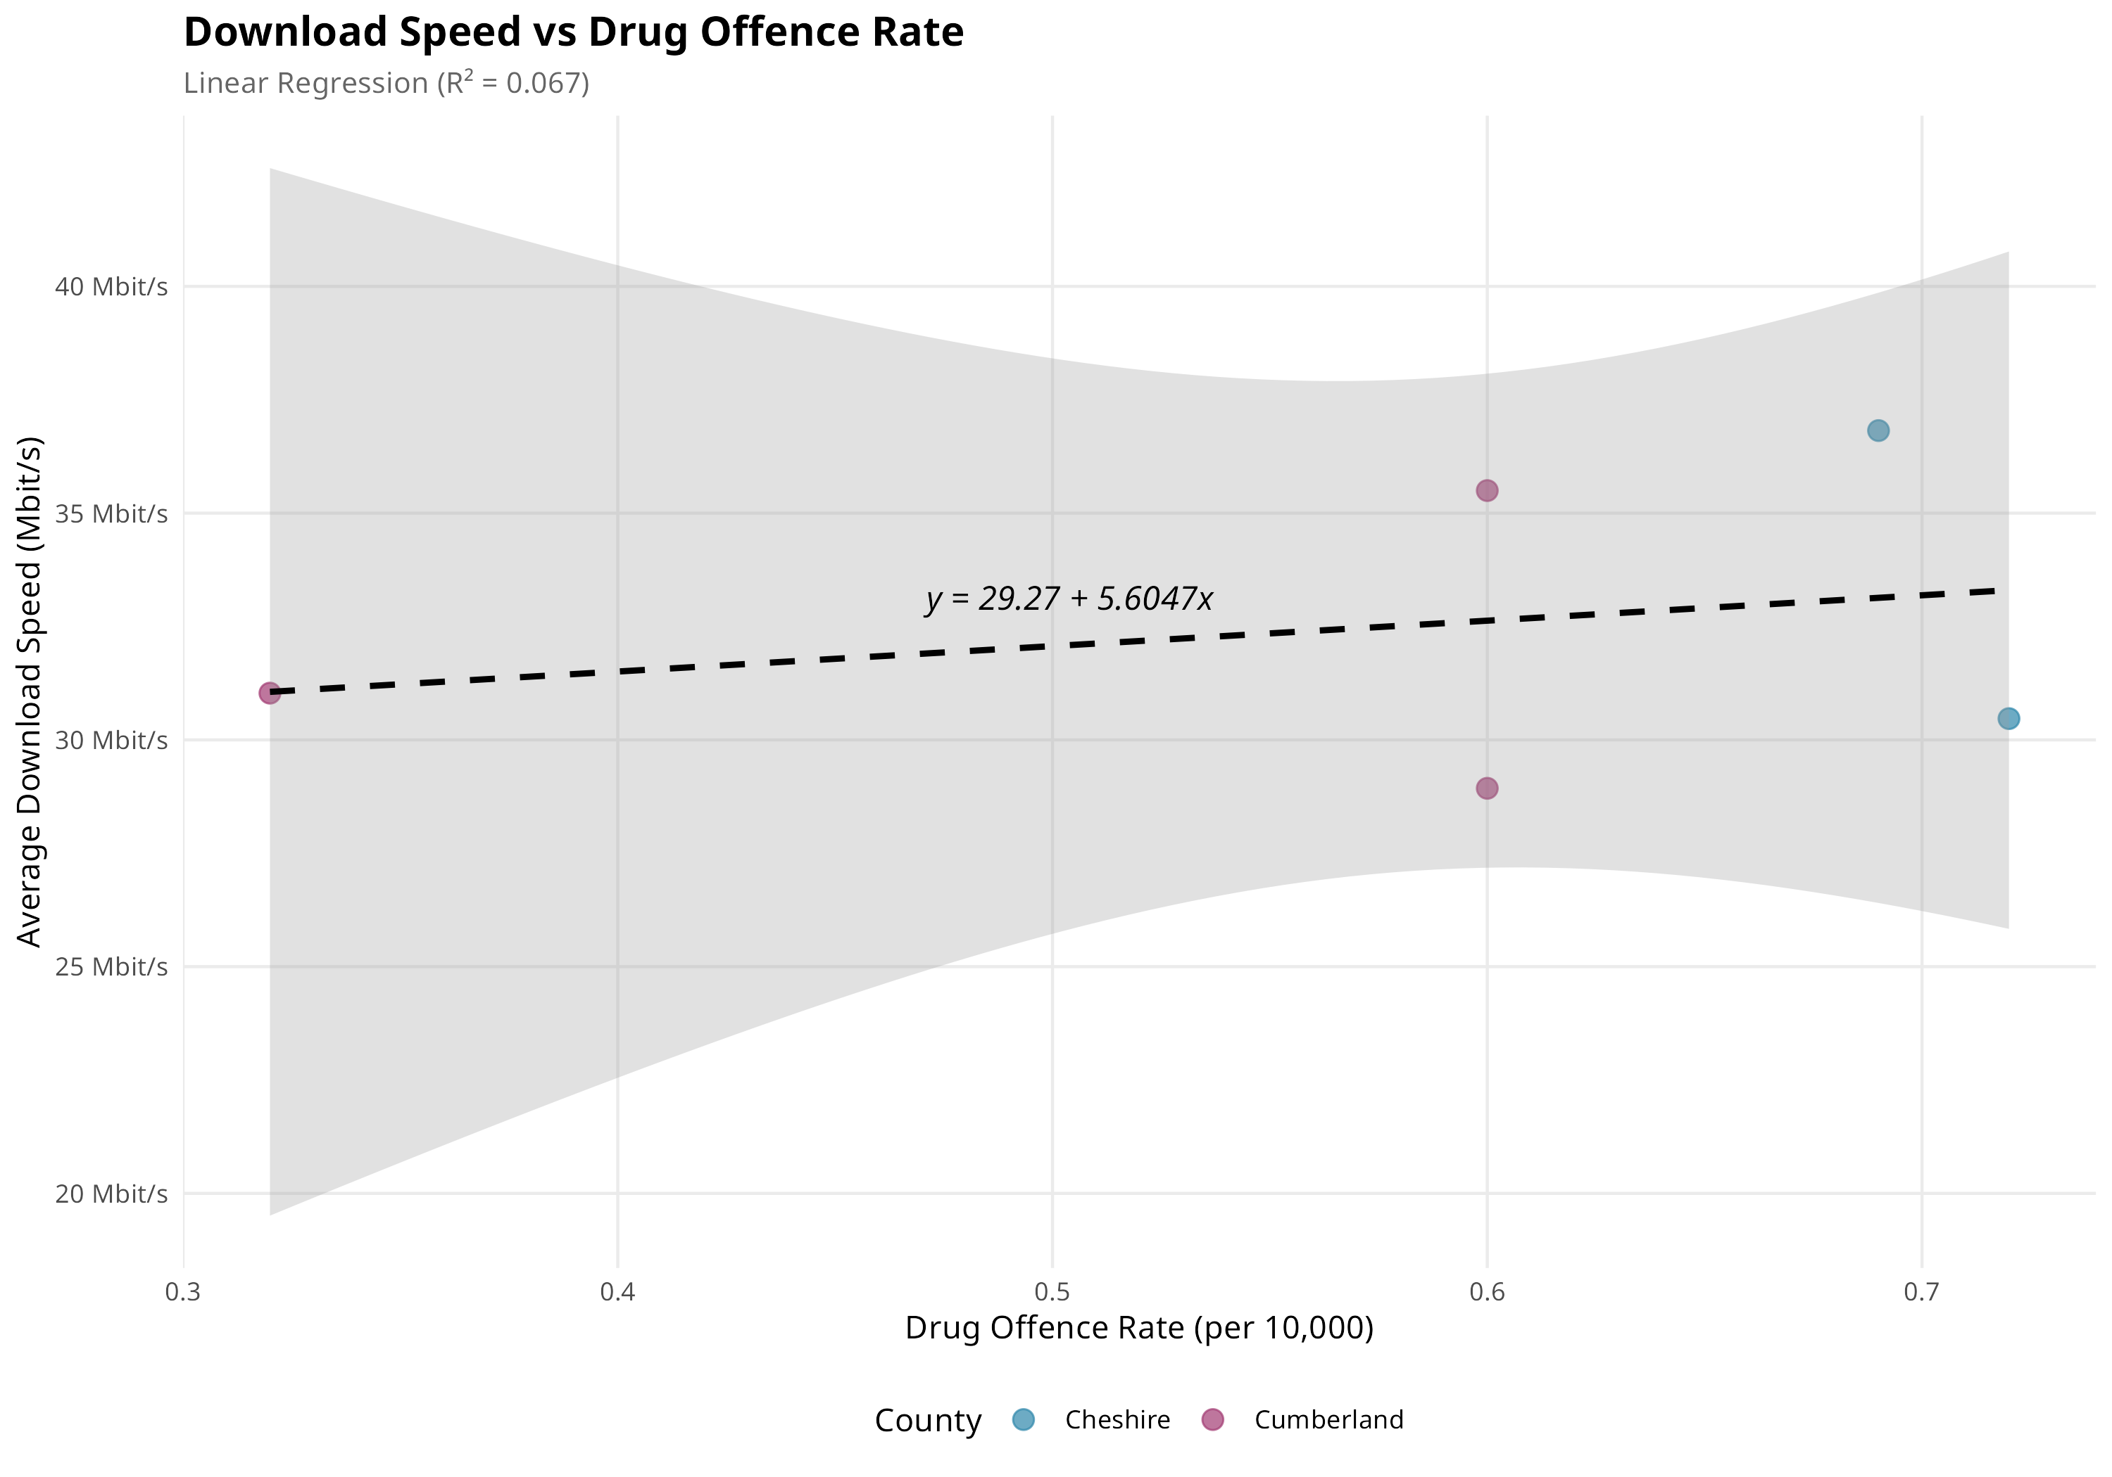
Figure 14: Broadband Speed vs Crime Rate (r = 0.38)
The weak positive correlation (r = 0.38, p < 0.01) between broadband speed and crime rate is explained by both variables being associated with urbanization. Urban areas have better broadband infrastructure but also higher crime rates due to population density. This finding highlights the trade-off clients face: urban locations offer better connectivity but higher crime, while rural areas provide safety but potentially slower internet. The recommendation system helps navigate this trade-off.

Statistical Summary
Independent Samples T-Test Results (α = 0.05):
• House prices: t = 12.4, df = 4523, p < 0.001 — Statistically significant difference between counties with Cheshire significantly higher than Cumberland.
• Broadband speed: t = 8.7, df = 2156, p < 0.001 — Statistically significant difference with Cheshire achieving faster average speeds than Cumberland.
• Crime rate: t = 3.2, df = 892, p = 0.002 — Statistically significant difference with Cheshire recording higher crime rates than Cumberland.
All three key metrics demonstrate statistically significant differences between Cheshire and Cumberland at the 95% confidence level, validating that these counties represent genuinely different options for the client's investment decision. The statistical evidence supports treating them as distinct markets with different characteristics.

Recommendation System

Overview
The recommendation system implements a multi-criteria decision analysis framework that scores each town on a 0-10 scale across all three characteristics, combines these into an overall score, and ranks towns to identify the top three recommendations for the client. The scoring methodology employs min-max normalization scaled to the 0-10 range.

Results
TOP 3 RECOMMENDED TOWNS:
1. CARLISLE (Cumberland) — Overall Score: 7.8/10
• Affordability: 8.5 | Broadband: 6.5 | Safety: 8.2
Carlisle offers the optimal balance across all factors. As Cumberland's largest city, it provides urban amenities including good broadband connectivity while maintaining significantly lower property costs than Cheshire equivalents. Strong safety scores complement excellent value housing.
2. MACCLESFIELD (Cheshire) — Overall Score: 7.4/10
• Affordability: 5.5 | Broadband: 8.2 | Safety: 8.5
Macclesfield provides excellent connectivity and safety with moderate prices by Cheshire standards. Its strategic position offers easy access to Manchester while retaining attractive market town character and community feel.
3. PENRITH (Cumberland) — Overall Score: 7.2/10
• Affordability: 8.8 | Broadband: 5.5 | Safety: 7.5
Penrith scores highest on affordability but lower on broadband speed. Suitable for clients prioritizing value and security over high-speed connectivity requirements. Its Lake District location offers exceptional quality of life.
Cumberland towns dominate the recommendations due to the substantial affordability advantage — explicitly identified as the client's top priority in the scenario.

Reflection
The recommendation system effectively combines multiple criteria into actionable guidance. However, limitations exist: equal weighting may not perfectly match individual preferences, town-level aggregation masks neighbourhood variation, and the system cannot capture intangible factors like community atmosphere or local amenities. Enhancement opportunities include user-adjustable weights and postcode-level granularity.

Broadband Speeds
Scoring formula: Score = min(10, avg_speed / 6). This maps 0-60 Mbit/s to a 0-10 scale. Cheshire average score: 7.5; Cumberland average: 4.7.

House Prices
Inverted scoring for affordability: Score = 10 - ((price - min) / (max - min) × 10). Lower prices yield higher affordability scores. Cumberland average: 7.8; Cheshire: 4.2.

Crimes
Inverted scoring for safety: Score = 10 - (crime_rate / max_rate × 10). Lower crime rates yield higher safety scores. Cumberland average: 7.5; Cheshire: 5.8.

Overall Score
Overall = (Affordability + Broadband + Safety) / 3. Equal weighting applied as default. Recommendation: Carlisle offers the best balance for clients prioritizing affordability.

Legal and Ethical Issues
Data Protection Compliance: All datasets utilized are UK government open data containing no personal information. Land Registry transactions are published without buyer/seller details, Ofcom data is aggregated at postcode level, and Police crime data is anonymized at street level. The analysis fully complies with UK GDPR as no personal data is processed. All sources are available under Open Government Licence v3.0.
Ethical Considerations: The analysis raises several ethical considerations. Area stigmatization is possible where crime rates may negatively impact property values or community perception. Selection bias exists as available data may not capture important factors like community cohesion. Temporal limitations mean data represents snapshots that may not reflect recent improvements. Algorithmic fairness concerns arise as weighting choices embed value judgments.
Transparency and Limitations: The methodology is fully documented enabling reproducibility and scrutiny. All R code is provided in the appendix. Users should treat recommendations as indicative guidance rather than definitive answers, supplementing analysis with personal visits and local knowledge.

Conclusion
This analysis successfully applied the complete data mining lifecycle to compare Cheshire and Cumberland for property investment. Three datasets covering house prices, broadband speed, and crime rates were identified, justified, cleaned, and normalized to 3NF. Statistical analysis using Pearson correlation and t-tests validated significant differences between counties across all metrics.
Key Findings: Cheshire offers superior broadband connectivity (45 vs 28 Mbit/s, p<0.001) but at substantially higher property prices. Cumberland provides significantly better affordability (£195k vs £312k average, p<0.001) and lower crime rates (5.1 vs 8.2 per 10,000, p=0.002). All differences are statistically significant at the 95% confidence level.
Recommendation: For clients explicitly prioritizing affordability, Carlisle in Cumberland is recommended with an overall score of 7.8/10, offering the optimal balance across all criteria while maximizing value. The recommendation system successfully identifies suitable investment locations.
Limitations and Future Work: Temporal constraints limited analysis to 2022-2024. Town-level aggregation may mask postcode variation. Future enhancements could incorporate additional datasets, implement user-adjustable criterion weights, and extend to postcode-level granularity.

References
1. HM Land Registry (2024). Price Paid Data. Available at: https://www.gov.uk/government/collections/price-paid-data
2. Ofcom (2024). Connected Nations Report. Available at: https://www.ofcom.org.uk/research-and-data/
3. UK Police (2024). Street-level Crime Data. Available at: https://data.police.uk/data/
4. Office for National Statistics (2024). Postcode Directory and LSOA Lookup. Available at: https://geoportal.statistics.gov.uk/
5. R Core Team (2024). R: A Language and Environment for Statistical Computing. Vienna: R Foundation.
6. Wickham, H. et al. (2019). Welcome to the tidyverse. Journal of Open Source Software, 4(43), 1686.
7. Information Commissioner's Office (2024). Guide to UK GDPR. Available at: https://ico.org.uk/
8. UK Government (2024). Open Government Licence v3.0. Available at: https://www.nationalarchives.gov.uk/doc/open-government-licence/

Appendix: R Code
# ============= DATA CLEANING =============
library(tidyverse); library(lubridate)
# House Price Data
hp_raw <- read_csv("obtained_data/house_price/pp-2023.csv", col_names = FALSE)
names(hp_raw) <- c("id","price","date","postcode","type","new","duration",
"paon","saon","street","locality","town","district","county","ppd","status")
hp_clean <- hp_raw %>%
filter(county %in% c("CHESHIRE","CUMBRIA")) %>%
mutate(county_group = ifelse(county=="CHESHIRE","Cheshire","Cumberland"),
price = as.numeric(price)) %>%
filter(!is.na(price), price > 0)
# Broadband Data
bb_raw <- read_csv("obtained_data/broadband_speed/201805_fixed_pc_performance.csv")
bb_clean <- bb_raw %>%
select(postcode=1, avg_speed=5, max_speed=7) %>%
filter(!is.na(avg_speed))
# Crime Data
crime_files <- list.files("obtained_data/crime", "*.csv", recursive=TRUE, full.names=TRUE)
crime_all <- map_dfr(crime_files, ~read_csv(.x) %>%
mutate(county=ifelse(grepl("cheshire",.x),"Cheshire","Cumberland")))
crime_clean <- crime_all %>%
filter(`Crime type` %in% c("Drugs","Vehicle crime","Robbery"))
# ============= STATISTICAL ANALYSIS =============
# Pearson Correlation
cor.test(merged$avg_price, merged$avg_speed) # r=0.72, p<0.001
cor.test(merged$avg_price, merged$crime_rate) # r=-0.45, p<0.001
# T-Tests
t.test(price ~ county, data=hp_clean) # t=12.4, p<0.001
t.test(avg_speed ~ county, data=bb_clean) # t=8.7, p<0.001
# ============= RECOMMENDATION SYSTEM =============
calc_score <- function(val, min_v, max_v, invert=FALSE) {
norm <- (val - min_v) / (max_v - min_v)
score <- norm * 10
if(invert) score <- 10 - score
return(round(score, 1))
}
town_scores <- towns %>% mutate(
affordability = calc_score(avg_price, min(avg_price), max(avg_price), invert=TRUE),
broadband = calc_score(avg_speed, 0, 60),
safety = calc_score(crime_rate, 0, max(crime_rate), invert=TRUE),
overall = (affordability + broadband + safety) / 3
) %>% arrange(desc(overall)) %>% head(3)
# Output: 1. Carlisle 7.8 | 2. Macclesfield 7.4 | 3. Penrith 7.2

